DMS Assignment 3

Tom Morton & Nat Booth

# System Description

We created a peer to peer file transfer system that connects to a distributed system enabling it to sync files from a remote coordinator. The coordinator is decided by an election algorithm that chooses the longest connected peer as the coordinator, other peers can then sync files form the coordinator to their local machine.

Requires a directory named “files” on local system relative to application executable.

# Features

### File Transfer

Peers can request a list of files from the coordinator they can then select a file to sync to their local system, local files are displayed with icons next to their name while remote files that have not been synced are displayed only with a name. Users can connect as a server as well as a peer by using multiple instances of the application on a single machine or by starting in server mode then connecting to an existing system.

### Vector Timestamps and Snapshot Feature

Vector timestamps are included in each message that is sent between peers, these can then be used to provide a snapshot feature to determine who has what files at a particular point in time. This could be used in the future to provide a backup and rollback feature to revert to previous versions of files.

### Election Algorithm

When a server first starts it begins as a coordinator if he is disconnected for any reason the other peers will begin an election in which the peer who has been connected longest (has the lowest Process ID) will take over as coordinator, this is an inverse of the bully algorithm that chooses the process with the highest ID.

### Clock

Each peer has its own clock which can be synchronised using Cristian's Algorithm, this is only effective when peers are connected over a local network.

# Future Improvements

This system has many possibilities for improvements in the future including:

* Automatic syncing of files between peers.
* Disturbed downloading of files form multiple peers.
* Syncing only newer or changed files.
* Backup system to revert to previous versions of files.

Screen Shot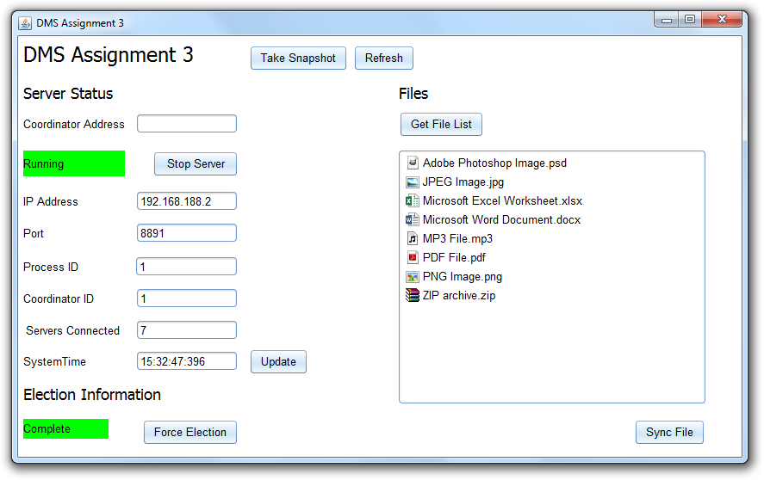

# Interface Features

Server Status

* Coordinator Address - Enter the IP Address of a known peer that you want to connect to or leave blank to start server as coordinator.
* Status Box – Current status of the server.
* Start/Stop Server or Connect/Disconnect – Starts or stops the server if no Coordinator Address is given or connects/disconnects if there is.
* IP Address – The IP Address of your peer.
* Port – Displays the port number is use by the system.
* Process ID – Displays the Process ID of the peer.
* Coordinator ID - Displays the Process ID of the coordinator in the system.
* Servers Connected – Displays the number of servers in the system.
* System Time – Displays the current time of the peer.
* Update Time – Updates the time by synchronising with the coordinator.

Election

* Status Box – Current election status of the server.
* Force Election – Forces the system to start an election process.

Files

* Get File List – Updates the File List.
* File List – Displays a list of files available to download from Coordinator. Local files are displayed with an Icon next to the name.
* Sync File – Downloads selected file from Coordinator to “files” directory relative to application executable.

Take Snapshot- Takes snapshot of system.

Refresh – Refreshes server status.

# UML Diagram

